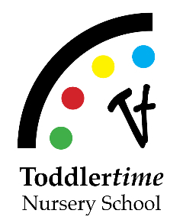
Yes, we would love your help!
Volunteering Opportunities at Toddlertime

Count me in for the following:

_____ Host Event at your home or yard such as year-end picnic, ladies’ night
_____ Parent Board Chair
_____ Work on Family Socials (year-end picnic, movie night etc.)
_____ Parent Socials – ladies’ night out, couple social
_____ New Canaan CARES Representative
_____ Community Service- food drive, Filling in the Blanks
_____ Teacher Appreciation Activities
_____ Food for an event
_____ Graphic Design/Photography
_____ I have a special skill or idea that I would like to share

Name:
Email:
Phone:
Class:

